Chapter 3, Problem 41.

Apply mesh analysis to find i_{o} in Fig. 3.87.

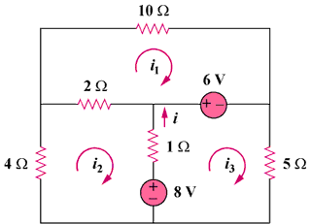

Figure 3.87
For Prob. 3.41.

